







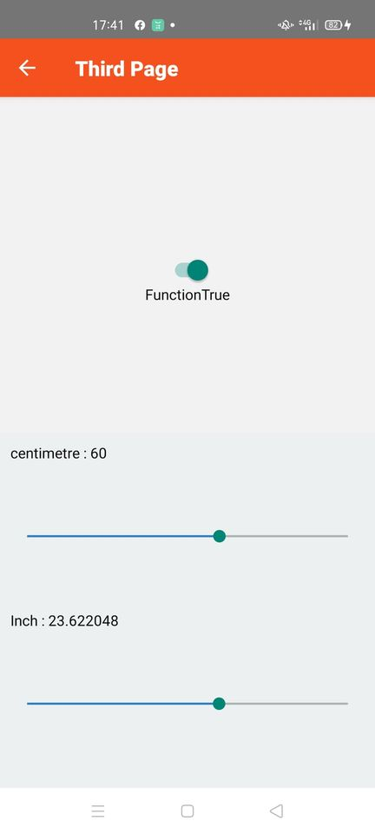



App

// Handling Android Back Button Press in React Native

// https://aboutreact.com/handling-android-back-button-press/

import 'react-native-gesture-handler';

import React from 'react';

import {NavigationContainer} from '@react-navigation/native';

import {createStackNavigator} from '@react-navigation/stack';

import FirstPage from './pages/FirstPage';

import SecondPage from './pages/SecondPage';

import ThirdPage from './pages/ThirdPage';

const Stack = createStackNavigator();

function App() {

return (

<NavigationContainer>

<Stack.Navigator initialRouteName="FirstPage">

<Stack.Screen

name="FirstPage"

component={FirstPage}

options={{

title: 'First Page', //Set Header Title

headerStyle: {

backgroundColor: '#f4511e', //Set Header color

},

headerTintColor: '#fff', //Set Header text color

headerTitleStyle: {

fontWeight: 'bold', //Set Header text style

},

}}

/>

<Stack.Screen

name="SecondPage"

component={SecondPage}

options={{

title: 'Second Page', //Set Header Title

headerStyle: {

backgroundColor: '#f4511e', //Set Header color

},

headerTintColor: '#fff', //Set Header text color

headerTitleStyle: {

fontWeight: 'bold', //Set Header text style

},

}}

/>

<Stack.Screen

name="ThirdPage"

component={ThirdPage}

options={{

title: 'Third Page', //Set Header Title

headerStyle: {

backgroundColor: '#f4511e', //Set Header color

},

headerTintColor: '#fff', //Set Header text color

headerTitleStyle: {

fontWeight: 'bold', //Set Header text style

},

}}

/>

</Stack.Navigator>

</NavigationContainer>

);

}

export default App;

First Page

// First screen which we will use to send the data

import React, { Component } from 'react';

//import react in our code.

import { StyleSheet, View, Button, Alert, Image, Text, BackHandler} from 'react-native';

//import all the components we are going to use.

export default class theFirstPage extends Component {

static navigationOptions = {

title: 'First Page',

};

endexit = () => {

Alert.alert(

'ออกจากโปรแกรม',

'คุณต้องการออกจากการทำงานของโปรแกรมหรือไม่',

[

{

text: 'No', onPress: () => console.log('ยกเลิก')

},

{

text: 'Yes', onPress: () => BackHandler.exitApp()

},

],

{cancelable: false },

);

return true;

};

render() {

const { navigate } = this.props.navigation;

return (

<View style={styles.container}>

<Image style={{ width: 250, height: 100,

marginTop: 35}}

source={require('./Logo.png')}

/>

<Text> </Text>

<Text> </Text>

<Button

title="การคำนวณเกรด"

onPress={() =>

navigate('SecondPage', {})

}

/>

<Text> </Text>

<Button

title="หน่วยวัดค่า นิ้ว และ เซนติเมตร"

onPress={() =>

navigate('ThirdPage', {})

}

/>

<Text> </Text>

<Button

title="จบการทำงาน"

onPress={this.endexit}

/>

</View>

);

}

}

const styles = StyleSheet.create({

container: {

flex: 1,

backgroundColor: '#fff',

alignItems: 'center',

padding: 10,

},

input: {

width: 200,

height: 44,

padding: 10,

marginBottom: 10,

backgroundColor: '#DBDBD6',

},

title: {

fontSize: 20,

marginTop: 10,

alignItems: 'center',

fontWeight: 'bold',

color: 'red',

},

});

SecondPage

// First screen which we will use to send the data

import React, { Component } from 'react';

//import react in our code.

import { StyleSheet, View, Button, TextInput, Alert, Text } from 'react-native';

//import all the components we are going to use.

export default class FirstPage extends Component {

constructor(props) {

super(props);

this.state = {sumscore:0, midscore:0, finalscore:0};

}

grade=()=>

{

var sumscore = parseInt(this.state.sumscore);

var midscore = parseInt(this.state.midscore);

var finalscore = parseInt(this.state.finalscore);

var score = sumscore + midscore + finalscore;

if(score < 50)

{

Alert.alert('คะแนนรวม : ' + score, 'เกรด: F');

}

else if(score < 60)

{

Alert.alert('คะแนนรวม : ' + score, 'เกรด: D');

}

else if(score < 70)

{

Alert.alert('คะแนนรวม : ' + score, 'เกรด: C');

}

else if(score < 80)

{

Alert.alert('คะแนนรวม : ' + score, 'เกรด: B');

}

else

{

Alert.alert('คะแนนรวม : ' + score, 'เกรด: A');

}

}

static navigationOptions = {

title: 'การคำนวณเกรด',

};

render() {

const { navigate } = this.props.navigation;

return (

<View style={styles.container}>

<Text style={styles.title}> การคำนวณเกรด </Text>

<Text style={styles.TextStyle}>คะแนนเก็บ</Text>

<TextInput

value={this.state.sumscore}

onChangeText={sumscore => this.setState({ sumscore })}

placeholder={'คะแนนเก็บ'}

style={styles.input}

/>

<Text style={styles.TextStyle}>คะแนนสอบกลางภาค</Text>

<TextInput

value={this.state.midscore}

onChangeText={midscore => this.setState({ midscore })}

placeholder={'คะแนนสอบกลางภาค'}

style={styles.input}

/>

<Text style={styles.TextStyle}>คะแนนสอบปลายภาค</Text>

<TextInput

value={this.state.finalscore}

onChangeText={finalscore => this.setState({ finalscore })}

placeholder={'คะแนนสอบปลายภาค'}

style={styles.input}

/>

<Button

title="CALCULATE GRADE"

onPress={this.grade}

/>

</View>

);

}

}

const styles = StyleSheet.create({

container: {

flex: 1,

backgroundColor: '#fff',

alignItems: 'center',

padding: 16,

},

input: {

width: 200,

height: 44,

padding: 10,

marginBottom: 10,

backgroundColor: '#DBDBD6',

},

title: {

fontSize: 20,

marginTop: 10,

alignItems: 'center',

fontWeight: 'bold',

color: 'black',

},

font1: {

fontSize: 18,

alignItems: 'center',

color: 'black',

},

font2: {

fontSize: 16,

alignItems: 'center',

fontWeight: 'bold',

color: 'black',

}

});

ThirdPage

import React, {useState} from 'react';

import {

Switch,

View,

Text,

SafeAreaView,

StyleSheet,

Slider

} from 'react-native';

const App = () => {

const [switchValue, setSwitchValue] = useState(false);

const [sliderValue, setSliderValue] = useState(1);

const toggleSwitch = (value) => {

setSwitchValue(value);

};

return (

<SafeAreaView style={{flex: 1}}>

<View style={styles.container}>

<Switch

style={{marginTop: 30}}

onValueChange={toggleSwitch}

value={switchValue}

/>

<Text>Function

{switchValue ? 'True' : 'False'}

</Text>

</View>

<View style={styles.slider}>

<Text style={{color: 'black'}}>

centimetre : {sliderValue}

</Text>

<Slider style={styles.container}

maximumValue={100}

minimumValue={0}

minimumTrackTintColor="#307ecc"

maximumTrackTintColor="#000000"

step={1}

value={sliderValue}

onValueChange={

(sliderValue) => setSliderValue(sliderValue)

}

/>

<Text style={{color: 'black'}}>

Inch : {sliderValue\*0.3937008}

</Text>

<Slider style={styles.container}

maximumValue={100}

minimumValue={0}

minimumTrackTintColor="#307ecc"

maximumTrackTintColor="#000000"

step={0.3937008 }

value={sliderValue}

onValueChange={

(sliderValue) => setSliderValue(sliderValue)

}

/>

</View>

</SafeAreaView>

);

};

const styles = StyleSheet.create({

container: {

flex: 1,

justifyContent: 'center',

alignItems: 'center',

},

slider: {

flex: 1,

padding: 10,

justifyContent: 'center',

backgroundColor: '#ecf0f1',

},

});

export default App;